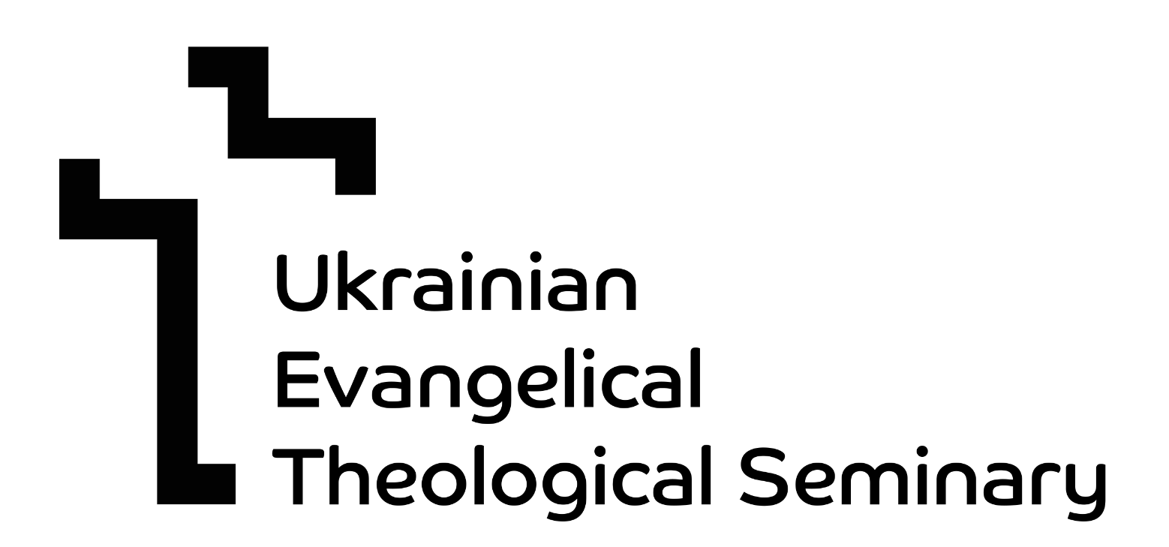

MEMORANDUM OF UNDERSTANDING

SAMFORD UNIVERSITY

and

UKRAINIAN EVANGELICAL THEOLOGICAL SEMINARY

This Memorandum of Understanding (MOU) is made by and between SAMFORD UNIVERSITY (herein after referred to as “Samford”), a nonprofit corporation organized under the laws of the State of Alabama, USA and UKRAINIAN EVANGELICAL THEOLOGICAL SEMINARY (hereinafter referred to as “PI”), an institution organized under the laws of Ukraine. Samford and PI are each referred to herein as a “party” and together as the “parties”.

Purpose and Intent

The purpose of this MOU is to set forth the general understanding of the parties ongoing and future areas of collaboration and cooperation, each of which shall be the subject of existing or future contractual agreements. Accordingly, this MOU does not create any binding obligations or entitlements for either party, but instead, memorializes the spirit of cooperation, professional compatibility, and independence that presently exists among the universities and which shall be manifested in separate specific agreements that shall govern the areas of collaboration.

Article 1 - Areas of Cooperation. The parties may cooperate and collaborate in a variety of ways including, but not limited to, the following:

- Student exchanges;
- Faculty exchanges;
- Joint academic activities such as courses, conferences, symposia, lecturers, and collaborative research; and
- Exchanges of educational materials and publications of common interest.

Article 2 - Arrangements and Funding. In furtherance of the implementation of the purpose and intent of this MOU, representatives of the parties may meet periodically to consider, formulate, and agree upon specific project agreements and programs of cooperation. Each specific agreement shall address the source of the finances required to successfully initiate and complete the performance of the agreement, including the allocation of financial responsibilities among the parties. Neither party is authorized or empowered to bind the other party without the prior written consent of the party to be bound. Absent a written agreement to the contrary, all costs, expenses and other financial obligations, including, without limitation, salaries, travel expenses and costs of living abroad shall be borne by the party who incurs such expense.

Article 3 - Management Collaboration and Governance. The parties may designate representatives to jointly manage and oversee their cooperative activities. Representatives of the parties may meet as and when necessary to review progress in the implementation and performance of existing cooperation and to identify new potential areas of cooperation that may exist among the institutions.

For Samford: For PI:
Samford University Ukrainian Evangelical Theological Seminary
SamfordGlobal Attn: Rev. Dr. Ivan Rusyn
800 Lakeshore Drive 57 Kvitky Tsisyk
Birmingham, AL 35229 USA Kyiv, Ukraine 04075
+1(205)726-4335 +380 50 529 9115
geo@samford.edu ivan.rusyn@uets.edu.ua
Homepage: www.uets.edu.ua

Article 4 - Term. This MOU shall be effective on the last signature date and shall continue in effect for a period of five (5) years thereafter unless terminated as provided for herein.

Either party can terminate this MOU for any reason upon prior written notice to the other party. At the end of its effective period, this MOU may be renewed upon written mutual agreement of the parties.

Article 5 - Whole Agreement. This Agreement constitutes the complete and entire understanding of the parties concerning the subject matter of this Agreement and supersedes all prior written and oral negotiations, understandings and agreements with respect thereto.
Article 6 - Signatories. Each party represents that the individuals signing this MOU have the authority to sign on its behalf in the capacity indicated.
This Agreement has been negotiated and executed by the Parties in English. In the event any translation of this Agreement is prepared for convenience or any other purpose, the provisions of the English version shall prevail.

UKRAINIAN EVANGELICAL
THEOLOGICAL SEMINARY SAMFORD UNIVERSITY

By:______________________ By:______________________
Rev. Dr. Ivan Rusyn Beck A. Taylor
President President

Date:____________________ Date:____________________

